Sample Social Media Posts
Download graphics at WashCoLib.org/Toolkit
____________________________________________________________________________________

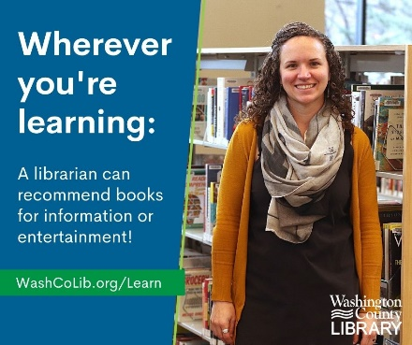
No matter how you’re learning, Washington County librarians are here to help! Get expert reading recommendations, learn how to check out ebooks, find sources for assignments, and so much more through your local library. Learn more: https://bit.ly/3c3ApTx

____________________________________________________________________________________

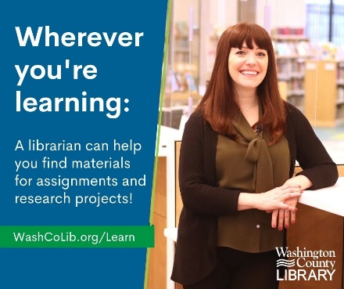
Need sources to help with a new assignment? Looking for recommendations when reading for fun? Washington County librarians can help connect you to the books and tools you need! Learn more: https://bit.ly/3c3ApTx

____________________________________________________________________________________

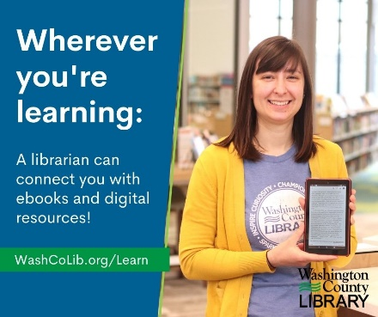
Not sure how to download ebooks while learning at home? Need primary sources for a project? Staff at Washington County Library can connect you to the digital tools you need. Learn more: https://bit.ly/3c3ApTx

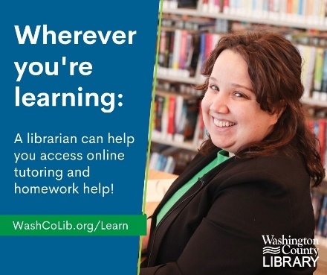
Access free, online tutoring services for grades K-12 in any subject through Homework HelpNow from Washington County Library. Visit Washington County Library to learn more: https://bit.ly/3c3ApTx

Take online practice tests and prep for major exams or AP tests with LearningExpress Library from Washington County Library. Learn more: https://bit.ly/3c3ApTx

____________________________________________________________________________________

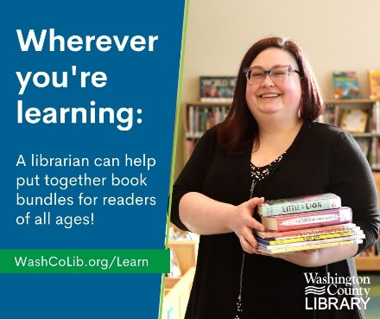
Librarians love to connect readers with the perfect book! They can recommend books based on interest, reading level, assignment, and more. Visit Washington County Library’s Learning from Home website to connect with a librarian: https://bit.ly/3c3ApTx

____________________________________________________________________________________

